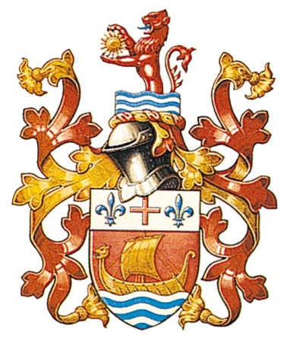
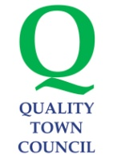
SIDMOUTH TOWN COUNCIL
WOOLCOMBE HOUSE
WOOLCOMBE LANE
SIDMOUTH
DEVON
EX10 9BB

Telephone: 01395 512424
Email: enquiries@sidmouth.gov.uk
Website: www.sidmouth.gov.uk

SIDMOUTH TOWN COUNCIL
WOOLCOMBE HOUSE
WOOLCOMBE LANE
SIDMOUTH
DEVON
EX10 9BB

Telephone: 01395 512424
Email: enquiries@sidmouth.gov.uk
Website: www.sidmouth.gov.uk
VAT Reg. No. 142 3103 24

How would you improve Sidmouth?
Sidmouth Town Council wants your suggestions for improving Sidmouth, Sidford, Sidbury and Salcombe Regis. Funding from new developments is being collected across East Devon and it is likely that in the future The Town Council will be asked for suggestions about how this could be best spent locally.
We are particularly interested in hearing your creative ideas for the improvement of the town for tourists and local residents. In particular what do you think would attract more visitors to the Sidmouth area, make visitors happier with their visit or encourage them to stay for longer? Or alternatively how local facilities could be improved for younger or older people?
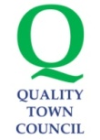
We are especially interested in the views of local community groups. If you are part of a group and would like a Councillor to come and speak to you before you fill in your form please contact us.
The Town Council is committed to ensuring that local people play a part in shaping a local vision for Sidmouth’s future development and will work hard to achieve some of your ideas in the future.
This is your opportunity to say what you would like to see.
When the consultation period is over we will put all of the ideas together and report them to Sidmouth Town Councillors. We will let you know what is happening with your ideas by email or letter so please make sure to complete the contact details below. All ideas must be received by Monday 30 June 2014 but if you have any questions please contact us.
Contact details
We need these so we can contact you if we need any more information about your idea.
Name:

Name of Group you represent (if relevant):

Age (optional):

Your address (including postcode) and telephone number:

Your e-mail (BLOCK CAPITALS):
What is your idea? (Please bear in mind that most of the money in the near future will only be able to spent on tourism)

Why do you think it would improve Sidmouth?

Who do you think your idea would benefit?

How much do you think your idea would cost?
Lower cost (£0 to £10,000)
Medium cost (£10,000 to £50,000)
Higher cost (Over £50,000)
Don’t know
Thank you for taking the time to fill in this form, we value your suggestions. Please send your completed form(s) back to us by Monday 30 June by e-mailing it to the Town Council, by dropping it into the Town Council offices or by posting it using the contact details on the top of this form.
When the consultation period is over, we will let you know what is happening with your ideas by email or letter. Initially we’ll put all the ideas together and report them to Sidmouth Town Councillors.

