Sarah Hardy
The Planning Inspectorate
3/09 Kite Wing
Temple Quay House
2 The Square
Bristol BS1 6PN

21st February 2014

Ref: APP/U1105/A/14/2211729

Dear Ms Hardy

Further to my letter of 10th May 2013 to East Devon District Council, I am writing to protest about the objections to planning for the noticeboard in Old Fore Street, Sidmouth. The reasons given were:

- That it is a hazard for delivery lorries
- That it is too untidy

My objections to the above-mentioned points were outlined in my previous letter (a copy of which is attached to this email).

However, I would like to point out that it is rather disingenuous of EDDC on the one hand to state that the noticeboard is a hazard and is untidy, whilst on the other hand still using it themselves as a public noticeboard. A photo of the EDDC notices below was taken on 4th January 2014.

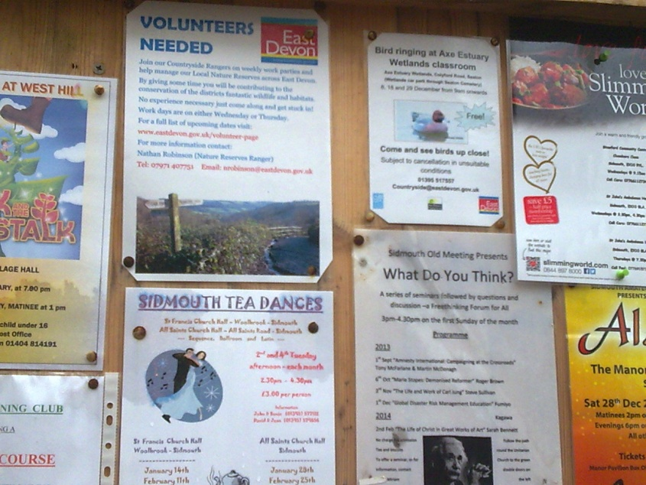

Notices have been regularly displayed for events at the Manor Pavilion, which is owned by East Devon District Council. Therefore, despite their own objections, EDDC has obviously found this noticeboard to be both prominently positioned and a useful place to display their own information.

Yours faithfully

Marianne Rixson

